Call for Poster Session Proposals
Deadline: February 28, 2017
SAALT is seeking to expand opportunities for engagement by participants at the National South Asian Summit 2017! This year, SAALT will host a poster session, an opportunity to showcase projects and work supporting and facilitating leadership development within the community. Posters should highlight work that is currently being done in the community, has been done in the past two years, or work that has started and will be completed by April 2017. The deadline to submit a poster proposal is February 28, 2017. Poster proposals that are selected will be informed the first week of March.
NOTE: SAALT is particularly interested in including programming by and for students, young advocates, and young professionals.
What is a poster session?
- An opportunity for individuals to share a specific program or project that they or their organization is working on through a visual display. Viewers should be able to understand the general focus of your project only by reviewing your poster.
- A summary of the project with an emphasis on the project’s impact.
- A way for individuals to present and informally discuss their work with community partners and community members.
How can I create a successful poster?
- Posters should be aesthetically pleasing and visually engaging.
- Posters should have one concise message.
- Poster title and content should be engaging, approachable, and easy to understand as a whole.
- Posters should be simple and uncluttered.
- Posters should answer basic questions such as:
  - Target group: Who is your project supposed to benefit?
  - Impact: How has your target group benefitted—or how will your target group benefit—from your project?
  - Process and programming: How was your project implemented?
  - Lessons learned: What have you taken away from implementing your project?

- See the following links for suggestions on how to create a successful poster:
  - Allegheny College
  - American College of Physicians
  - North Carolina State University
  - University of North Carolina Graduate School
  - Washington NASA Space Grant Consortium
- One suggestion is to design the content for your poster using a MS PowerPoint template (click here to download) and follow these instructions:
  - You can use the template to design your poster. The page size of the template is the same print size of the poster board that SAALT will provide for you to display your poster presentation.
  - You can then take the file to a printer and print on a sheet of paper that is 46” x38”. To prevent cropping when printing, be sure you have a 1 inch margin around the edges of the poster.
General Requirements:
- Maximum of 1 poster per project.
- All poster presentations will be mounted on 36”high x 48”wide tri-fold black presentation boards. SAALT will provide the boards and adhesive materials as well as a room and a time in the Summit agenda for poster assembly (see picture below).
- Presenter(s) will need to bring all the needed material to create their poster.
Note: Posters must be physical, hard copies, not digital.
- Poster presentations will be displayed on tables (not easels) for the duration of the summit.
- Individuals who submit posters must be able to attend both Saturday and Sunday (April 22-23) in order to discuss their projects and answer questions during the designated poster session walkthroughs (TBD).
- Posters may have a maximum of two presenters.
Sample Tri-Fold:
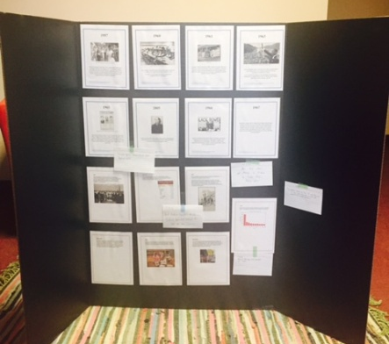
For information about Summit 2017, please visit www.saalt.org/programs/south-asian-summit/.
Please submit all applications and direct all questions to summit@saalt.org.
The National South Asian Summit 2017 is hosted by South Asian Americans Leading Together (SAALT)
INSTRUCTIONS
- In the Word version of this application, please complete the following information by placing your cursor in the grey cell beneath each field and typing your responses.
- The abstract should provide a clear and concise description of your project and include the pieces listed in the “successful poster” section above.
- For proposals involving collaboration, only the primary contact (primary presenter/facilitator) needs to submit a proposal.
- Up to one (1) co-presenter is permitted, but not required.
- Priority consideration will be given to clear, concise, and fully completed proposal ideas that reflect the Summit 2017 theme and topic areas and are submitted by the deadline.
Please note that sessions will take place on April 22-23, 2017 and by submitting a proposal you are confirming that, if selected, you are available to conduct your session on either day.
Poster Proposal
Poster title
Abstract (300 words or less)
Presenter (first and last name)
Presenter’s organization or affiliation
Presenter’s email address | Presenter’s phone number
Brief bio detailing relevant experience and expertise (As it will appear in Summit documents, if selected—200 word maximum)
Co-Presenter (first and last name)
Co-presenter’s organization or affiliation
Co-presenter’s email address | Co-presenter’s phone number
Brief bio detailing relevant experience and expertise (As it will appear in Summit documents, if selected—200 word maximum)

