Cultivate skills. Connect with community. Create change.

2017-2018 Young Leaders Institute Overview and FAQ

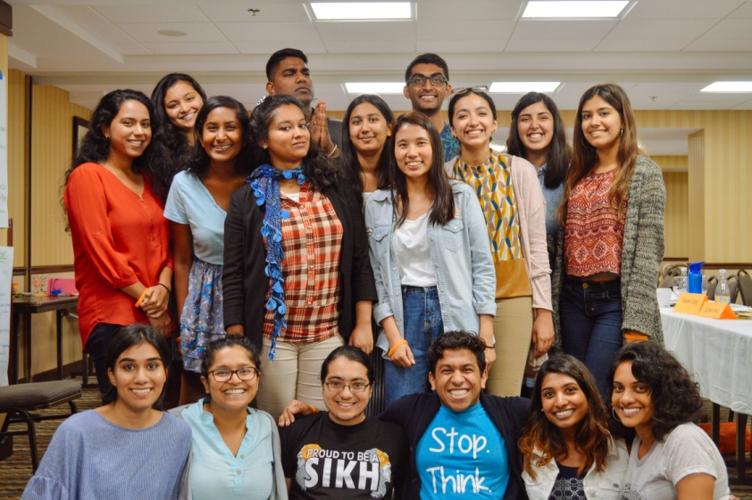
“YLI became a place where I found community amongst like-minded South Asian Americans who are passionate about justice.”
- Jasveen
2016-2017 YLI Fellow

“YLI was an important opportunity for me to learn the tools and strategies to create the change I wanted to see”
- Anusha
2016-2017 YLI Fellow

2017–2018 Young Leaders Institute
Combating Islamophobia

SAALT’s Young Leaders Institute (YLI) is an opportunity for undergraduate students and other young adults in the US to build leadership skills, connect with activists and mentors, and explore social change strategies around issues that affect South Asian and immigrant communities in the US. The Institute is designed to cultivate skills to deepen knowledge and awareness; strengthen and nurture relationships with diverse communities; and empower young leaders to be agents of change.

The 2017–2018 Young Leaders Institute theme is: Combating Islamophobia. Students will develop and implement projects to combat Islamophobia through civic engagement on their campuses and in their communities. We emphasize that civic engagement goes beyond elections and election cycles and is defined by individuals who choose to organize themselves and others toward collective action to weigh in, engage, and voice their opinions on how to address pressing issues that need to be improved, replicated, or addressed in their community.

SAALT is seeking 15–18 outstanding, diverse young leaders to join the 2017–2018 Young Leaders Institute. Please review this FAQ for more information about the Young Leaders Institute, this year’s theme, who can apply, and how to apply.

Application deadline: June 16, 2017

Frequently Asked Questions

What is SAALT?
South Asian Americans Leading Together (SAALT) is a national, nonpartisan, non-profit organization that fights for racial justice and advocates for the civil rights of all South Asians in the United States. Our ultimate vision is dignity and full inclusion for all.

SAALT is the only national, staffed South Asian organization that advocates around issues affecting South Asian communities through a social justice framework. SAALT’s strategies include advocating for just and equitable public policies at the national and local level; strengthening grassroots South Asian organizations as catalysts for community change; and informing and influencing the national dialogue on trends impacting our communities. To learn more about SAALT, please visit www.saalt.org.

What is the Young Leaders Institute?
SAALT’s Young Leaders Institute is a unique opportunity for 15–20 young leaders in the US to explore issues that affect South Asian American communities; engage in peer exchange; hone leadership skills; and learn strategies and approaches to social change. The 2017–2018 Institute will be the sixth time this annual leadership development program will be hosted by SAALT.

Who can apply for the Young Leaders Institute?
US undergraduate students and other young adults 18–22 years of age* interested in creating change among South Asian Americans on their campuses or in their communities.

*Note: Priority consideration is given to young adults 18–22 years of age in the US. SAALT welcomes applications from young leaders who may not have access to undergraduate studies, as well as those who are enrolled in undergraduate programs. Applications of young adults who are older and/or in graduate school will be accepted and considered.

Why is the Institute important?
SAALT is committed to the leadership development and support of young adults as agents of progressive change among South Asians in the US. The Institute encourages participants to explore their current leadership qualities, challenge themselves to evolve their leadership skills, learn from fellow young leaders, and commit to advancing social justice in real ways on their campus and in their community.

What is the 2017–2018 theme?
The 2017-2018 Young Leaders Institute theme is “Combating Islamophobia.” Islamophobia or the systemic hostility and discrimination enacted toward those who are or are perceived to be Muslim is a complicated and fraught issue in the South Asian American community. The origins of Islamophobia within our communities has roots in colonialism and internalized racism woven with American institutionalized racism beginning with slavery and now foreign policy. This long and complicated evolution has led to anti-Muslim violence at an all-time high in the United States. Last year, the FBI reported a 67% increase in anti-Muslim hate crimes and SAALT’s recently released report “Power, Pain, Potential” documented 207 incidents of violence and xenophobic political rhetoric aimed at our communities during the 2016 presidential election cycle, of which 95% were animated by anti-Muslim sentiment. SAALT also documented a troubling uptick in anti-Muslim acts of violence, harassment, and intimidation on college campuses across the nation.

Anti-Muslim or Islamophobic policies have always been a part of United States history, increasing in visibility after the attacks of September 11th and soaring again now. These include but are not limited to the Patriot Act, National Security Entry-Exit Registration System (NSEERS), the Department of Justice Guidance on the use of race by law enforcement, Countering Violent Extremism (CVE) program, immigration laws and enforcement like the current Muslim ban being appealed in court, local law enforcement surveillance, profiling, and stop and frisk policies.

Combating Islamophobia requires work within and outside our communities to ensure that we address our own biases and internalized oppression while also fighting systems and policies that diminish, criminalize, and discriminate against Muslims and those perceived to be Muslim. As we continue to head into uncertain and even dangerous times ahead, it is more important than ever that the South Asian American community effectively combats Islamophobia in all its forms. The 2017-2018 YLI cohort will work to understand the perspectives of individuals most impacted by Islamophobia, the systemic nature of Islamophobia and how it manifests in policies at all levels including college campuses, and develop ways to challenge and disrupt Islamophobia in our families and communities.

What is civic engagement?
The Institute theme folds in a critical civic engagement component. Civic engagement is defined for the current purposes by an interest and willingness by individuals, residents, and constituents to engage with decision-makers, stakeholders, and peers (appointed and elected, campus-based and outside) as well as decision-making processes to make their voices, opinions, and priorities heard. Civic engagement is not limited to or predicated upon activities or efforts that involve voting or the voting process, or US citizens (who are generally, apart from some exceptions, the only individuals who can vote in the US). At its essence, civic engagement is defined as individuals who choose to organize themselves and others toward collective action to weigh in, engage, and voice their opinions on how to address pressing issues that need to be improved, replicated, or addressed in their community.

For the purposes of campus-based projects around addressing and building immigrant justice in South Asian and campus communities, civic engagement can involve a variety of actions. Please note, the following are examples only. Applicants are encouraged to submit their own innovative and creative project ideas, including but not limited to projects that promote civic engagement through art!

- Organizing students to partner with local community-based organizations on problematic local, state, or national policies criminalizing Muslims
- Raising concerns with the campus administration on campus police actions and policies that disproportionately target Muslim students regardless of their activities or behavior
- Organizing a speak-out for students to voice how they see xenophobic practices & sentiment manifest on their campuses and in the actions of administrators
- Organizing letter-writing or postcard campaigns in support of Muslims
- Hosting forums/ town halls for campus community members to share their experiences of campus policies and discuss how to advocate for change
- Supporting local organizing efforts to institute legislation that advances racial justice such as hate-free zones, anti-racist training for law enforcement, and prohibitions on racial profiling

Note: Competitive applications will reflect detailed project proposals that include identifying campus or community groups that work with South Asian and/or other marginalized immigrant populations and develop a strategy for a civic engagement project in collaboration with that group.

How does the Institute work?
The Young Leaders Institute requires full participation in the following commitments:
- On-site 3-day intensive training in the Washington, DC metro area on July 19–21, 2017
- Creation of a project combating Islamophobia through civic engagement on your campus or in your community that meet specific education/awareness and social change objectives
- Completion of campus or community projects by April 30, 2018
- Monthly group report-back, peer exchange, and support calls (August–November; February–April)
- Completion of written report-back, program evaluation, and additional requested materials

What is your graduation policy?
Participants must be able to commit to and fulfill all above requirements in order to graduate from the Institute. Participants who complete all requirements will be considered 2017–2018 Young Leaders Institute Fellows and have the opportunity to further engage with SAALT’s work.

Note: SAALT recognizes that many young leaders have work, family, and other important obligations that may be connected to income, health, and so forth. SAALT is committed to working with each young leader accepted into the program to support their fulfillment of commitments or to work together on alternatives in the event of extenuating circumstances.

Why do I want to be a 2017–2018 Young Leaders Institute Fellow?
Participants will develop leadership skills; understand key issues affecting South Asian American communities in a social change context; and connect their campus and community with South Asian organizations and leaders. A few examples of the work of fellows after graduating from the Institute:

- Served as an AmeriCorps Public Allies program at the Florida Immigrant Coalition
- Served as a summer intern at SAALT and various South Asian organizations
- Organized campus workers to fight for living wages
- Organized a multi-lingual health resources fair for immigrant community members
- Hosted an arts showcase uplifting immigrant narratives
- Completed an anthology highlighting the experiences of queer Desis in the US

How much does this cost? What does SAALT provide?
SAALT will provide the following to accepted candidates:

- Round trip air, train, or bus fare to the July 19-21 on-site training. Mode of transportation will depend on your departure point and will be chosen by SAALT (round-trip fare is restricted to traveling from a city to DC and returning to the same city).
- Hotel accommodation (shared room) for the nights of July 18, 19, and 20
- On-site training from July 19–21
- Breakfast, lunch, and dinner on July 19 and 20; breakfast and lunch on July 21
- Monthly group calls for report backs, peer exchange, and support
- All other expenses, such as public transportation and taxi fares, additional meals or activities, and extended hotel stay are the participant’s responsibility

How do I apply? What is the application deadline?
Interested applicants should review information about SAALT, the Institute, and complete an application packet found here. All applications should be submitted as one PDF document to sonia@saalt.org with the subject line “YLI 2017–2018 application.” Completed application packets are due no later than June 16, 2017. Final candidates will be announced by the last week of June 2017 on our website. Due to the volume of applications, only final candidates will be contacted directly.

What does a competitive application look like?
A competitive application will demonstrate an interest in effecting progressive change on a college campus or community. It will reflect a commitment to combating Islamophobia through civic engagement in the South Asian American community. It will include ideas about realistic, scaled projects to enact this change and have the initiative, commitment, and resourcefulness to implement those ideas. It will also show a willingness to share experiences and learning from trainers and peers. Competitive applications will also seek to connect their projects with a member organization of the National Coalition of South Asian Organizations (NCSO) wherever possible. SAALT does realize that because capacity and South Asian populations vary greatly across the country, an NCSO organization may not be in or near an applicant’s city of residence and will take this into account.

How does the Institute support diversity?
The 2017 Institute welcomes diversity in regard to race/ethnicity, country of origin, immigration status, socioeconomic status, sexual orientation, gender identity, ability, and religion.

